A000-Pac-Poly-Marquesas-Nukuhiva-Bust- Ohia Wood-Mid 20th c

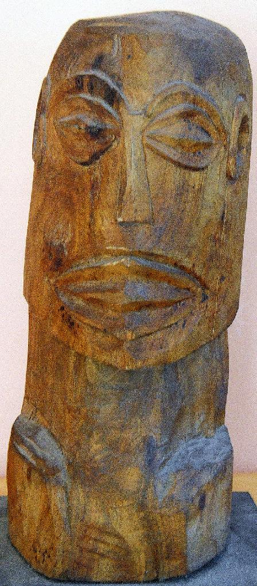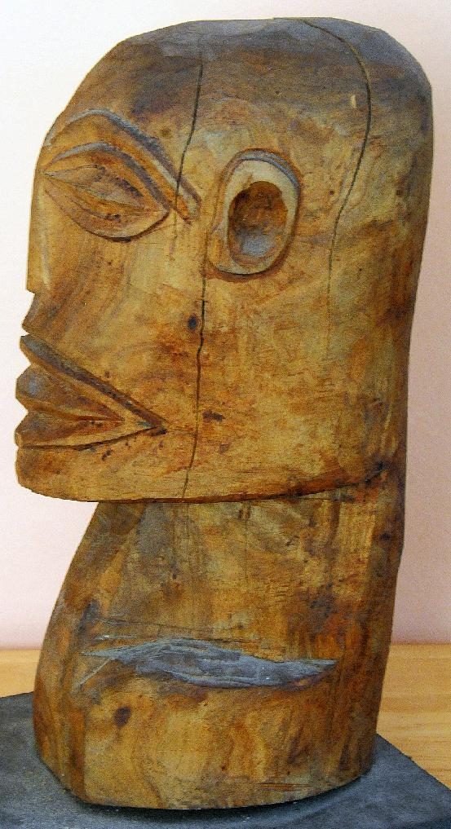

A000-Pac-Poly-Marquesas-Nukuhiva-Bust- Ohia Wood-Mid 20th c

Case No.: 13

**Accession No.**

**Formal Label:** Pac-Poly-Marquesas-Nukuhiva-Bust- Ohia Wood-Mid 20th c

**Display Description:** This bust of hard Ohia wood may represent a deified chief whose facial features emphasize oval eyes and arched brows, a small, flattened nose and a horizontal mouth, partially open. This facial depiction may derive either from a shrunken head of a sacrificed human, who was the source of the chief’s power (Linton and Wingert 1946:36), or it may, more probably, derive from the visage of the mummified chief himself who was “later given a final funeral at which much wealth, in the form of pigs, was displayed” (Moore 1995: 147).

**LC Classification:**

**Date or Time Horizon:**

**Geographical Area:**

**Map:**

**GPS coordinates:**

**Cultural Affiliation:**

**Media:**

**Dimensions:**

**Weight:**

**Condition: original**

**Provenance:** ex Bishop Museum, 1973.

**Discussion:**

**References:**

Linton,, Ralph and Paul S. Wingert. 1946. *Arts of the South Seas.* New York: Museum of Modern Art.

Moore, Albert C. 1995. *Arts in the religions of the Pacific: Symbols of Life*. London: Cassell.